Setting up 2nd VM.

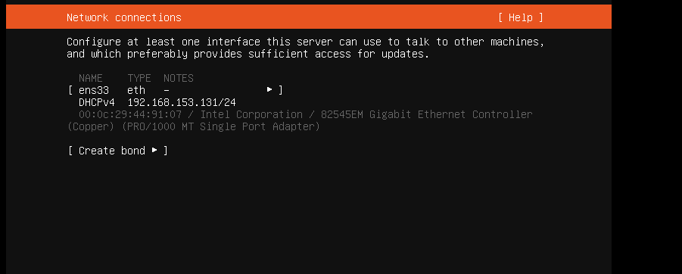

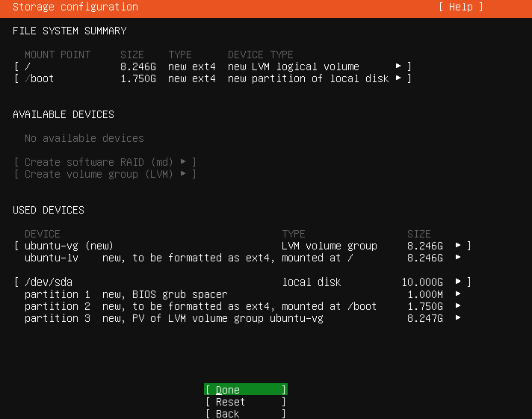

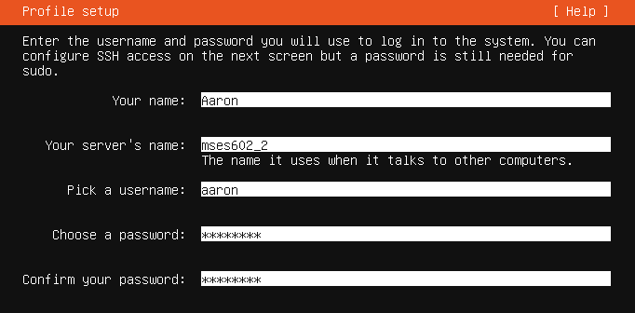

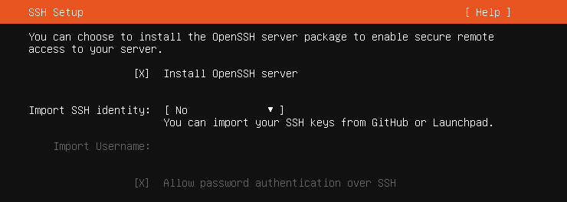

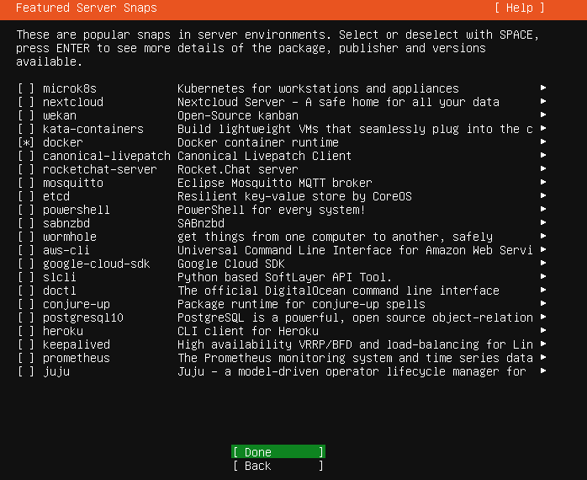

Signing in to Ubuntu.

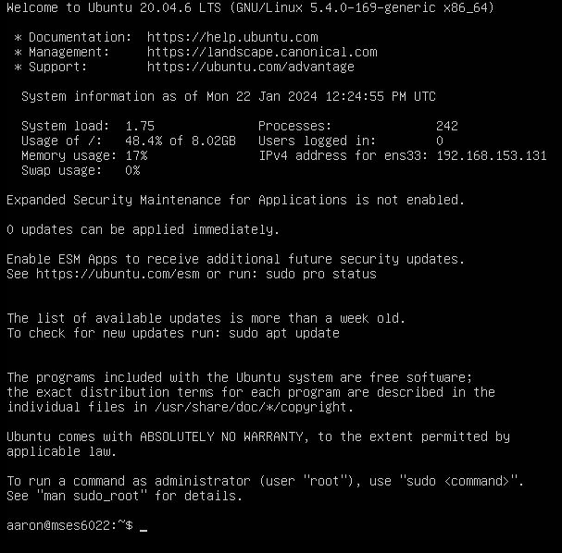

Signing in with puTTY

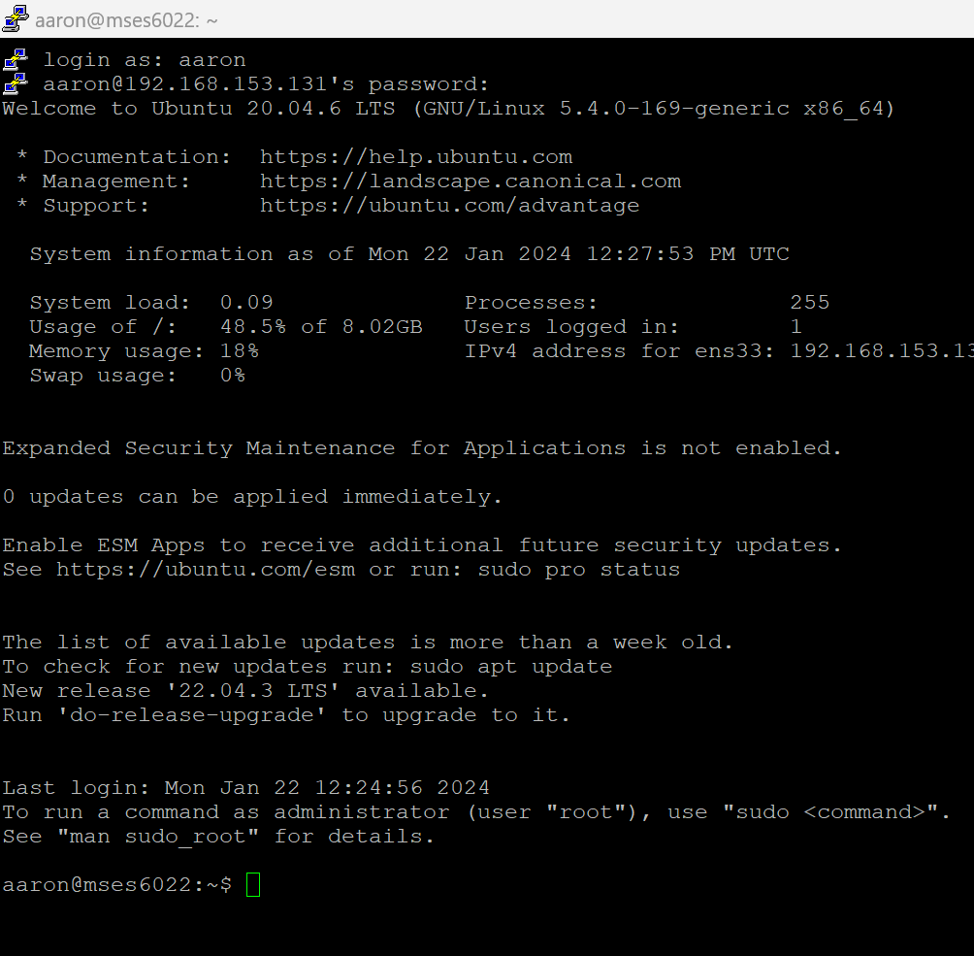

Installing docker.

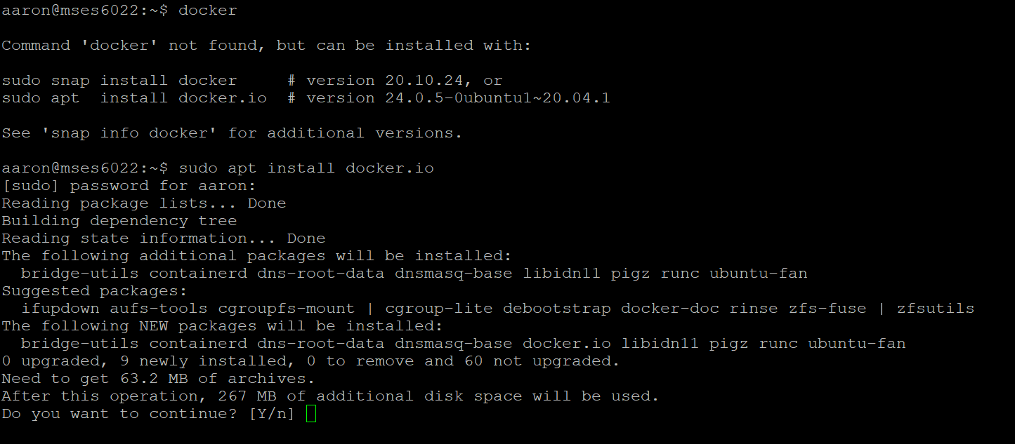

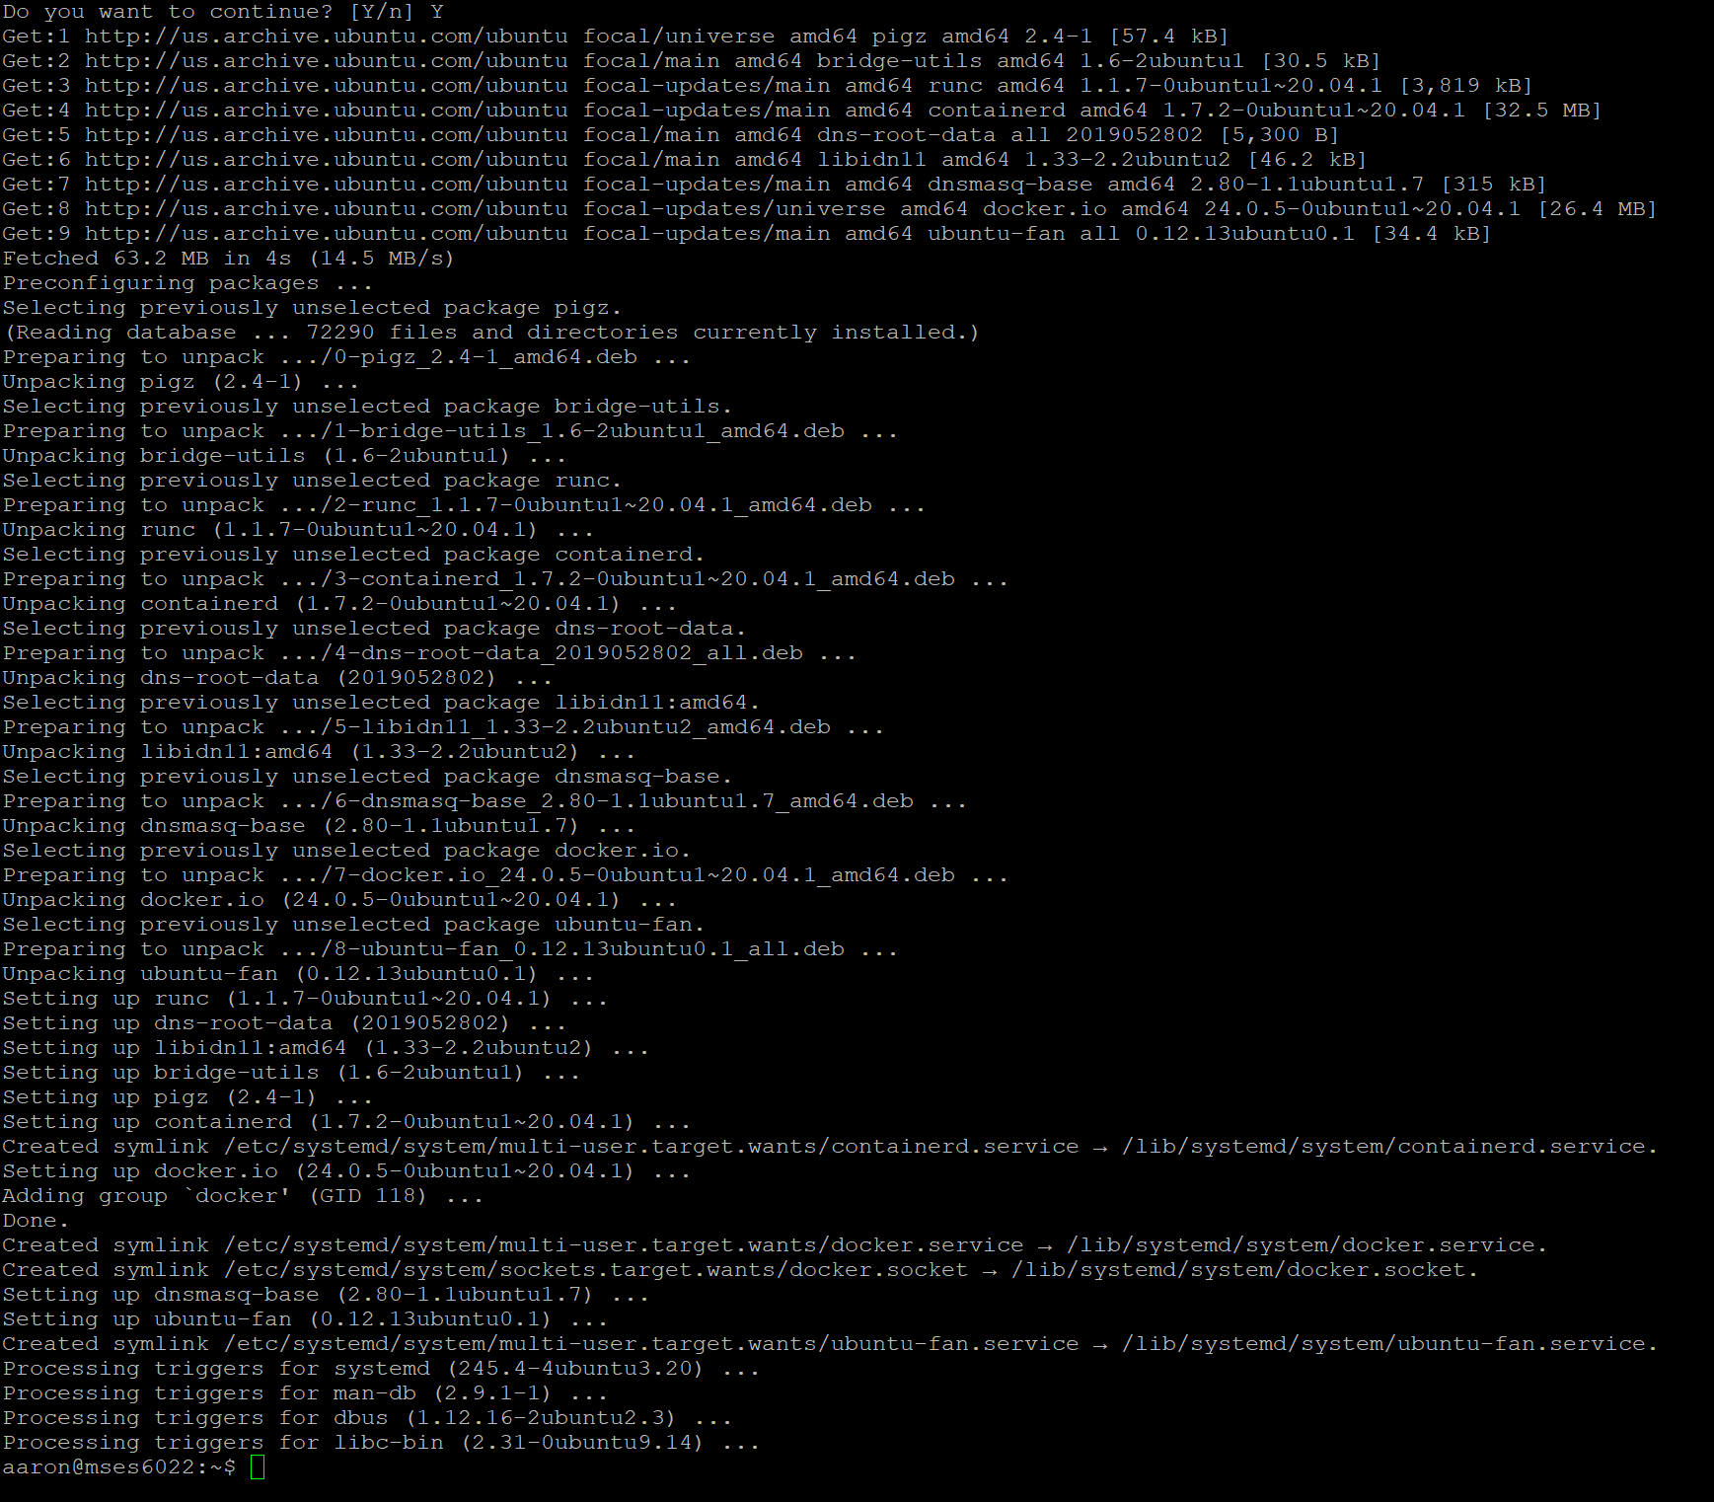

Docker information

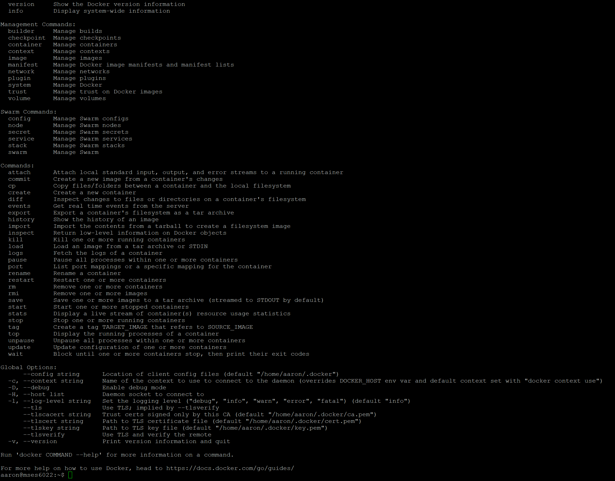

After reading the web, I uninstalled docker on VM2 and used the script on the Docker website.

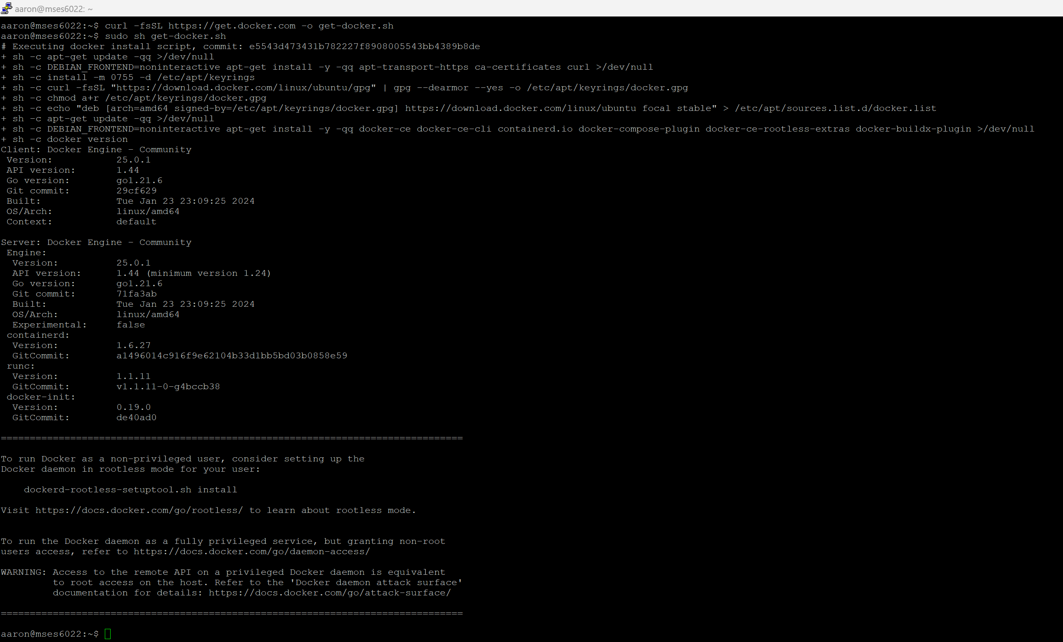

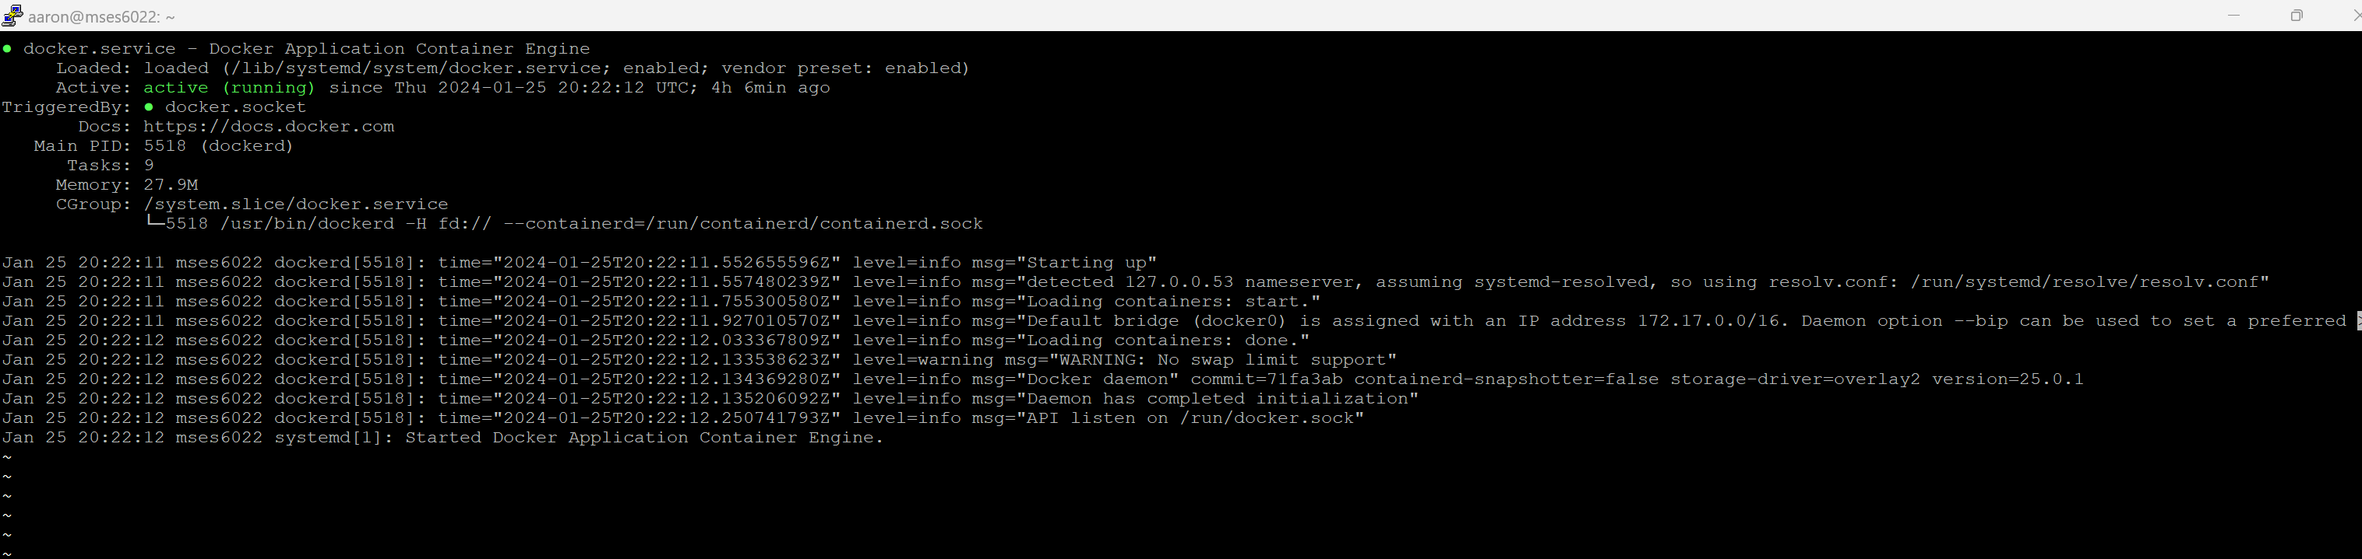

SSID: TVAANA

Protocol: Wi-Fi 6 (802.11ax)

Security type: WPA2-Personal

Manufacturer: Intel Corporation

Description: Intel(R) Wi-Fi 6E AX211 160MHz

Driver version: 22.250.0.4

Network band: 5 GHz

Network channel: 157

Link speed (Receive/Transmit): 216/544 (Mbps)

IPv6 address: 2601:280:c500:4fb0::97ee

2601:280:c500:4fb0:5e67:cdad:46db:e282

Link-local IPv6 address: fe80::8409:dade:ba20:eb7%18

IPv6 DNS servers: 2001:558:feed::1 (Unencrypted)

2001:558:feed::2 (Unencrypted)

IPv4 address: 10.0.0.124

IPv4 DNS servers: 75.75.75.75 (Unencrypted)

75.75.76.76 (Unencrypted)

Physical address (MAC): 70-32-17-7B-87-DE

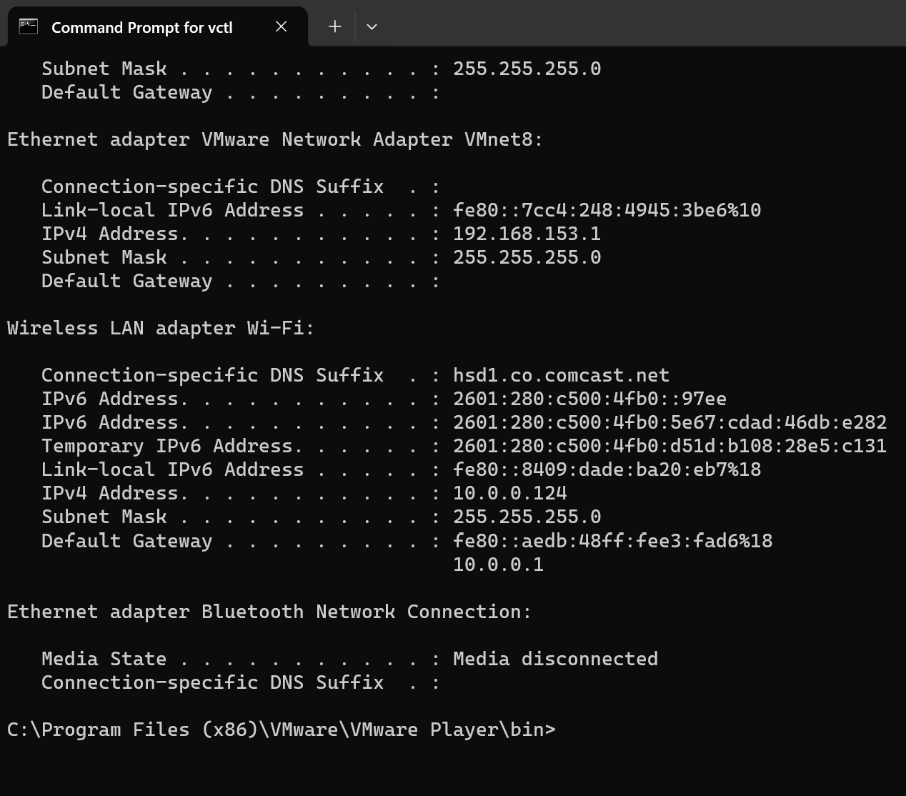

In Linux I had to install to be able to use ‘ifconfig’ to find the VM IP address.

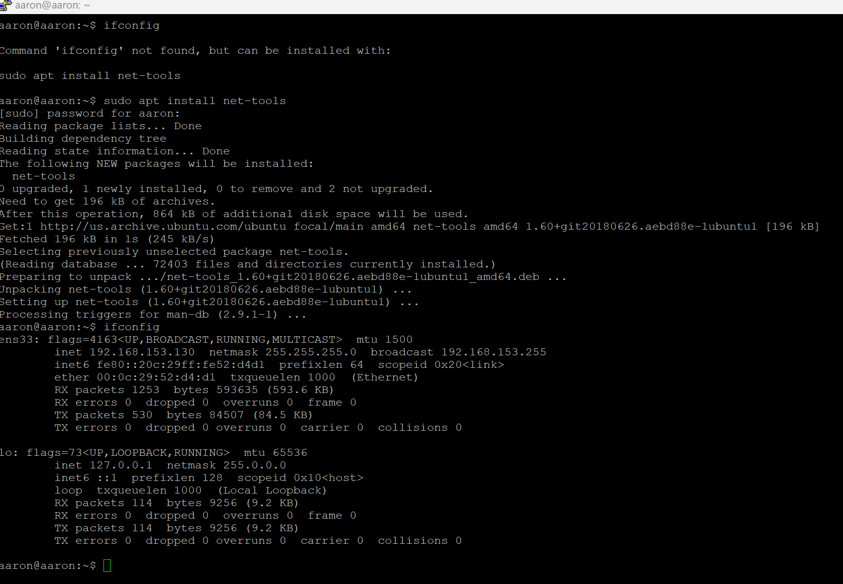

VM2

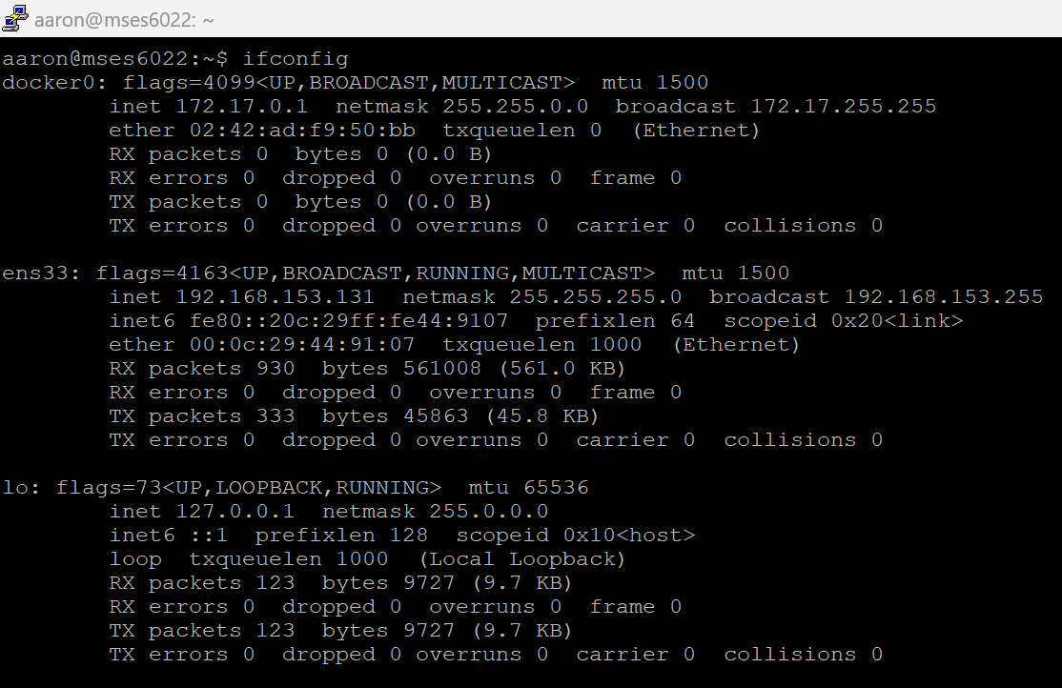

Virtual machine 1

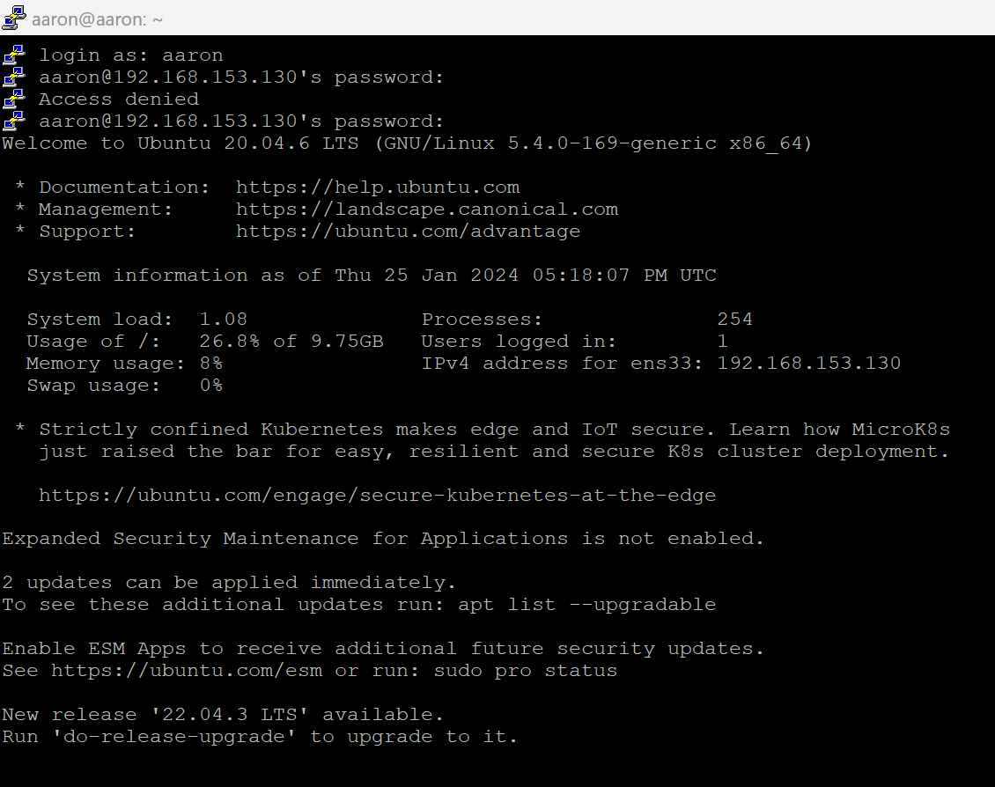

Virtual machine 2

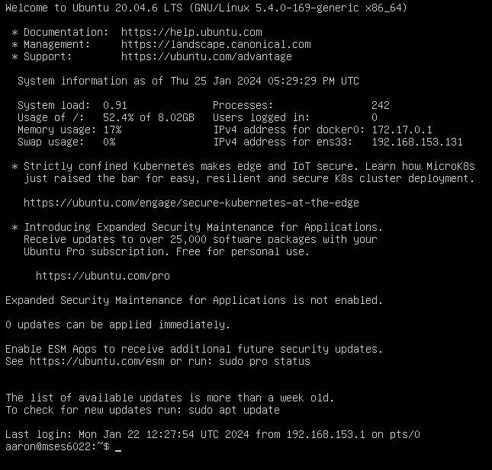

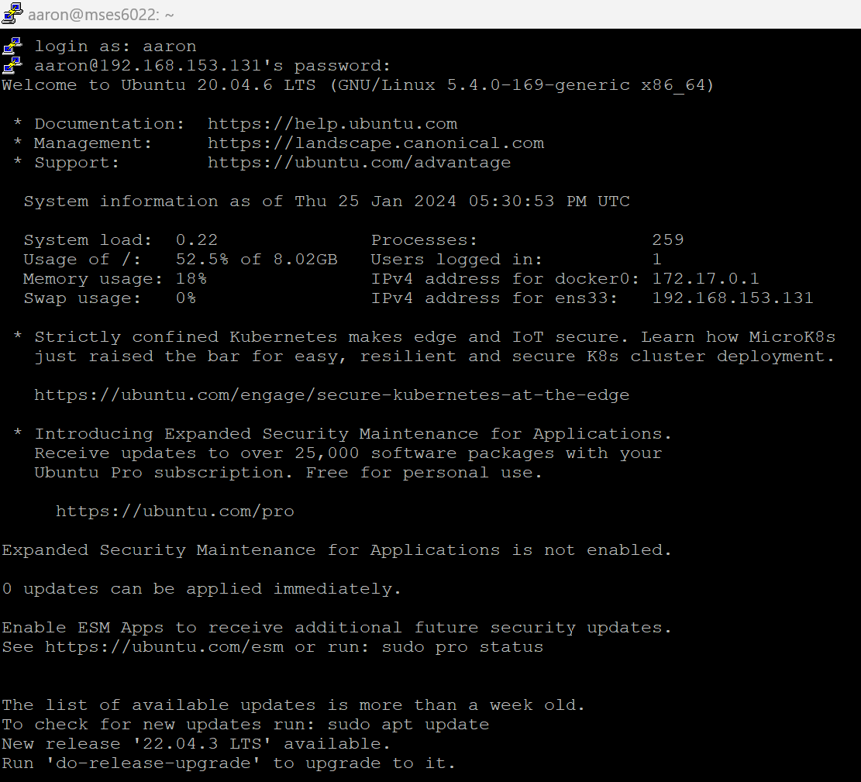

Used ‘ping’ in host C:\ to VM 2 ip 192.168.153.131

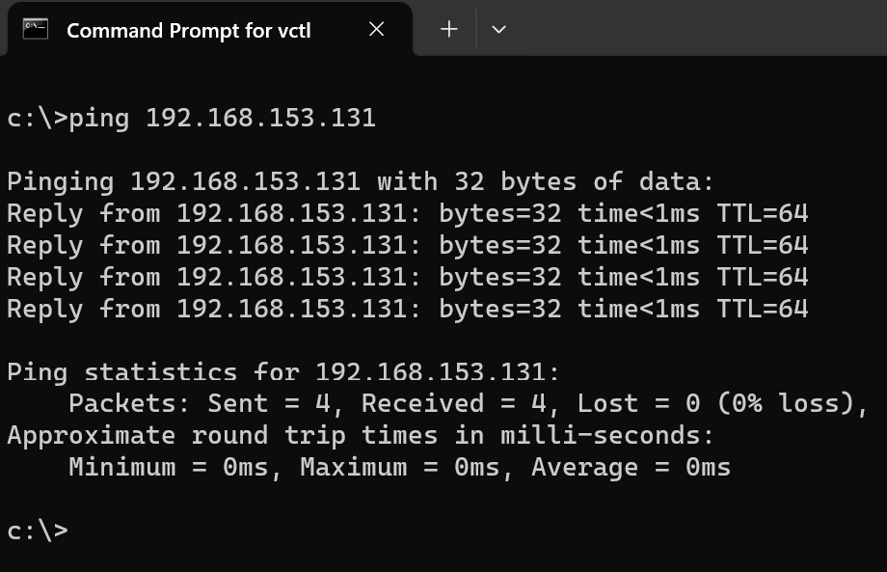

Used ‘ping’ in host C:\ to VM 1 ip 192.168.153.130

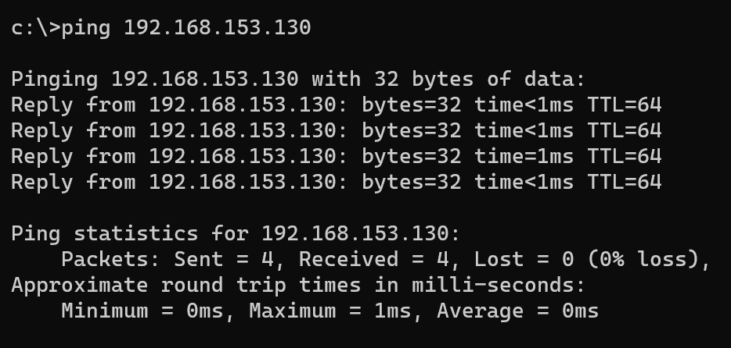

After not being able to ping in the current NAT setup, I changed both VM to Bridge. Because I did that I had to change the ip addresses.

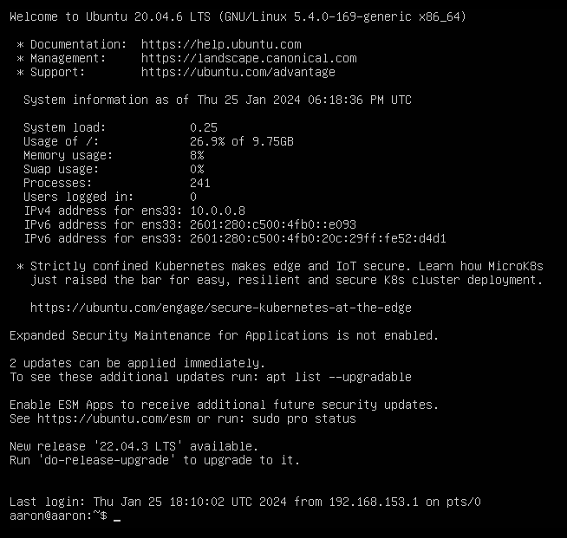

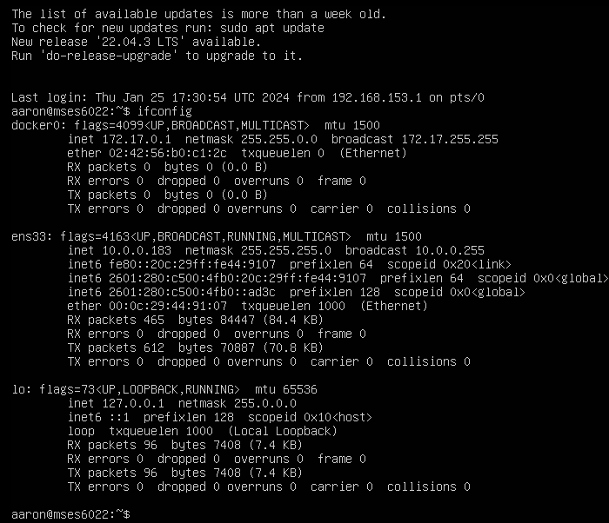

This shows the ‘Docker’ ip address

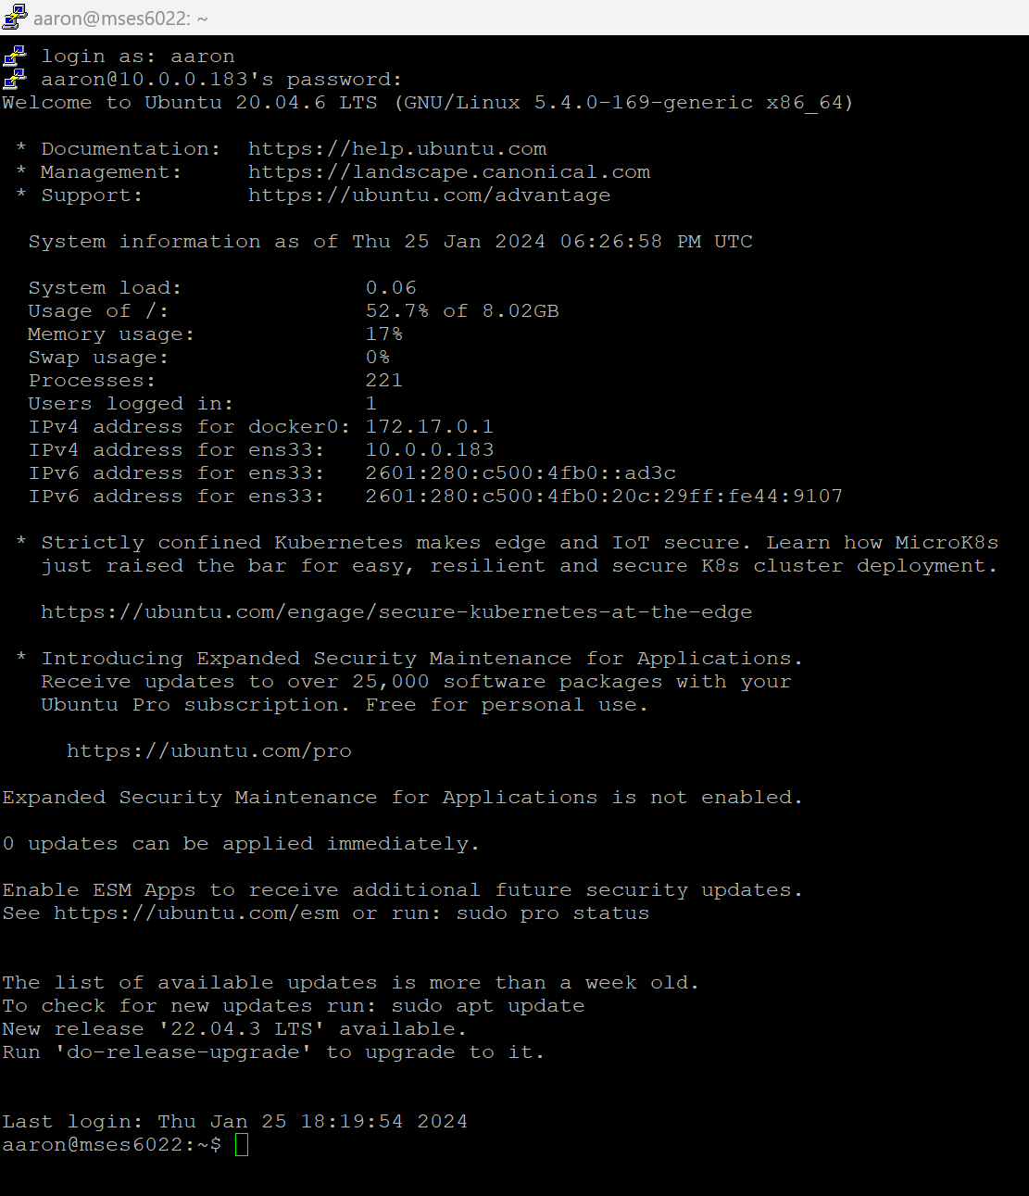

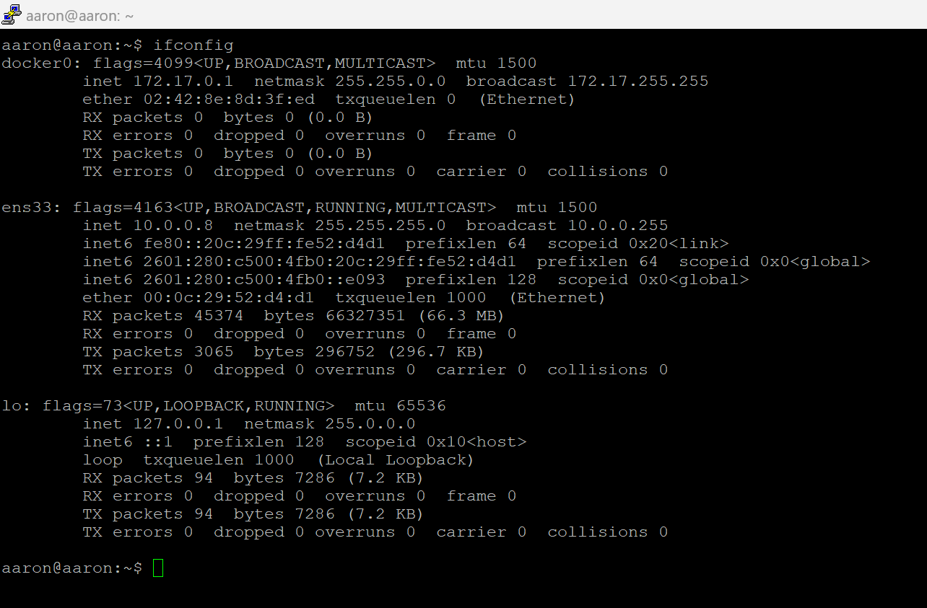

Per my readings online, I think Linux Ping is continuous and does not stop pinging. When you do in in Windows it does, so the behave differently.

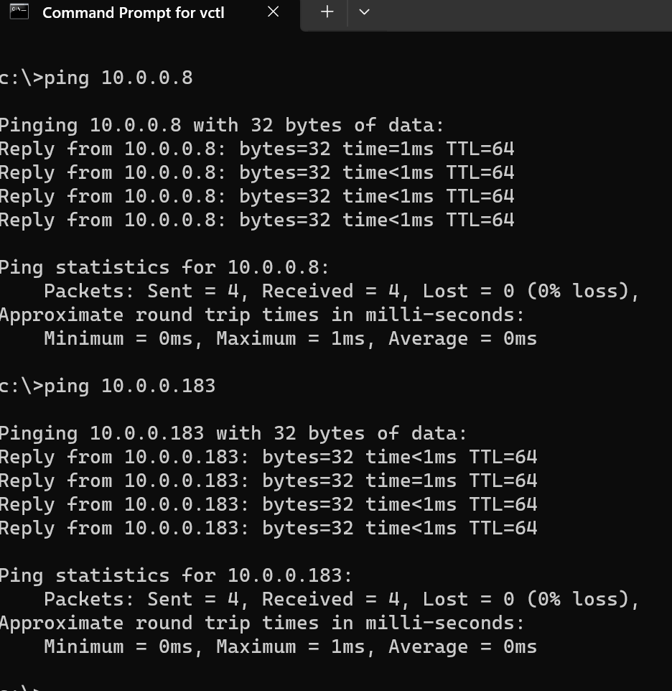

VM2 pinging VM1

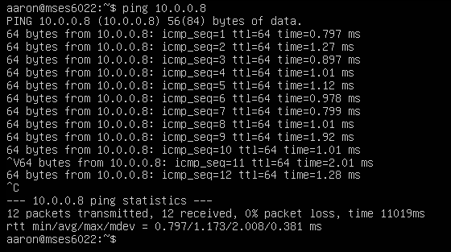

VM1 pinging VM2

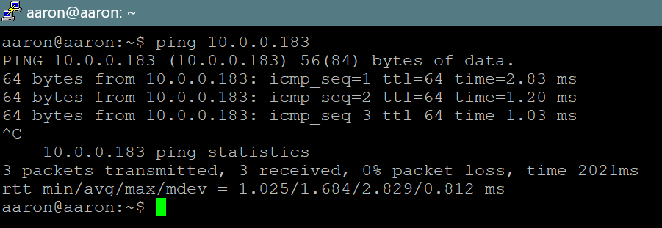

I was able to ping from VM to Host by turning off firewall.

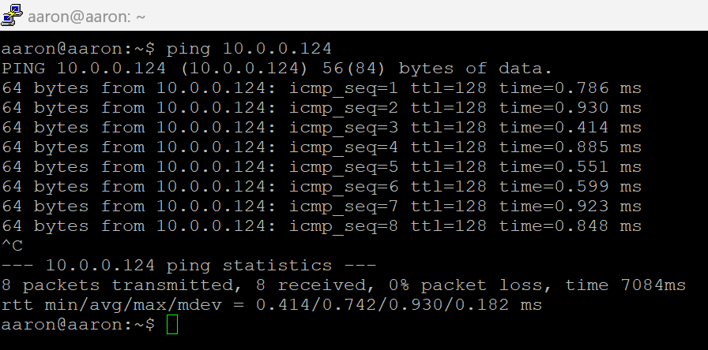

Pinged Google from VM.

